Performance Table

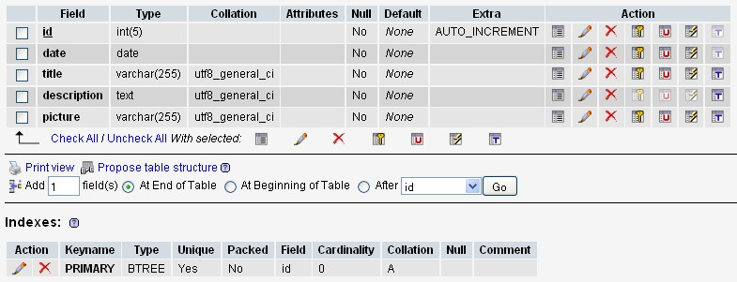
Id = unique sequence number, auto increment, primary key.
Date = performance date (yy-mm-dd)
Title = performance title
Description = performance description
Picture = performance picture file name as stored in data folder
Song Table

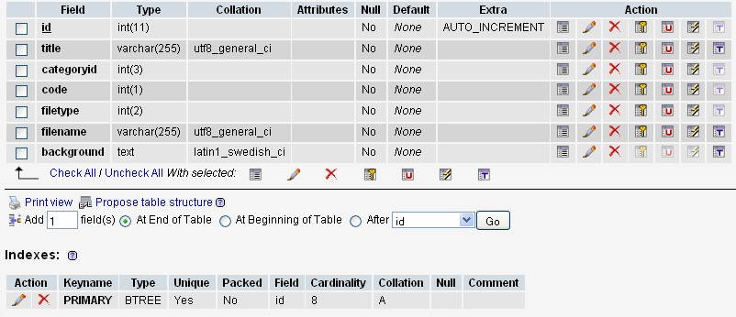

Id = unique sequence number, auto increment, primary key
Title = song title or cribcard title
Categoryid = song’s category
1 = Songs of working life
2 = Freedom from Oppression & Social Justice
3 = Peace
4 = Reconciliation
5 = Harmony with the environment
6 = Songs of farewell or remembrance
(this category could be dynamic = stored in category Table)
Code = public / member
1 = Public
2 = Member
File type = type of files
1 = audio
2 = lyric
3 = music sheet
4 = music sheet + audio
5 = cribcard
File Name = file name as it is stored in data folder
Background = Background description of the song
Member Table

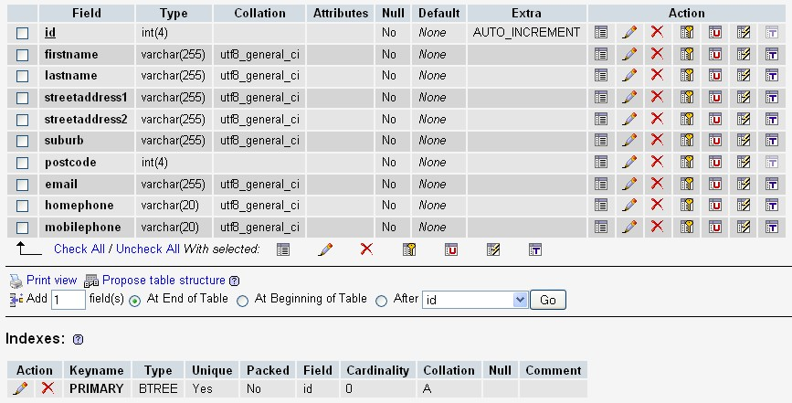

Id = unique sequence number, auto increment, primary key
Firstname = Member’s First Name
Lastname = Member’s Last Name
StreetAddress1 = Member’s home address 1
StreetAddress2 = Member’s home address 2
Suburb = Member’s home suburbname
Postcode = Member’s home postcode
Email = Member’s email address
Homephone = Member’s Home phone number
Mobilephone = Member’s Mobile Phone Number
Booking Table

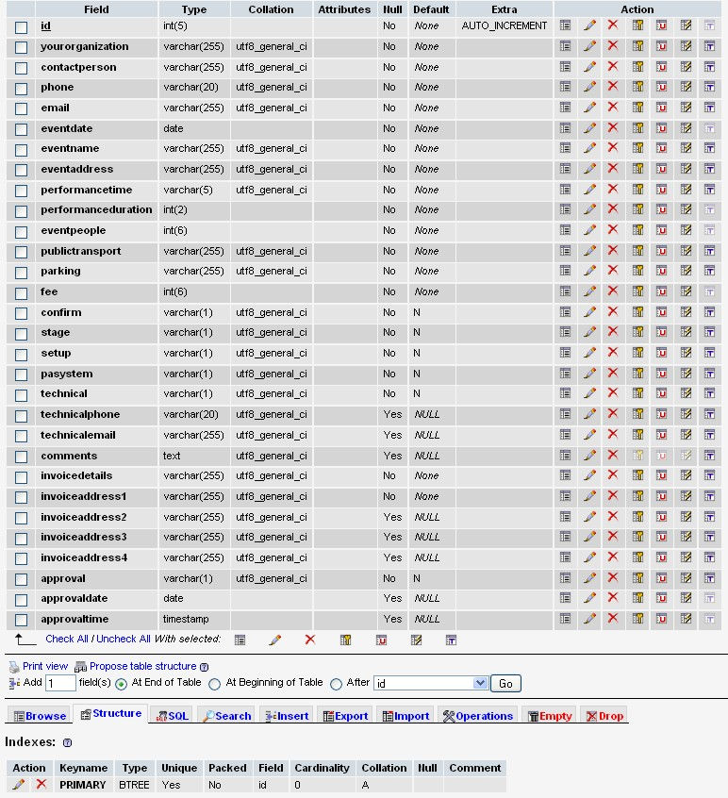

Id = unique sequence number, auto increment, primary key
yourorganization = Your organisation
contactperson = Contact Person
phone = Contact Peron’s Phone
email = Contact Person’s Email
eventdate = Event Date
eventname = Event Name
eventaddress = Event Address (address, suburb in one field)
performancetime = Time of performance (hh:mm format, 2 pm = 14:00)
performanceduration = Duration of performance (in rounded hour)
eventpeople = How many people at the event
publictransport = Is the venue accessible by Public Transport (variable character 255 chars)
parking = Parking Availability (variable character 255 chars)
fee = Fee Quoted (in A$)
confirm = Booking Confirmed (Y or N, default is N).
stage = Is there a stage? (Y or N, default is N).
setup = Do we set up with people in the room (Y or N, default is N).
pasystem = Are we working with a PA system (Y or N, default is N).
technical = Is there a technical person to contact (Y or N, default is N).
technicalphone = Technical Contact phone
technicalemail = Technical Contact email
comments = Any additional information and comments?
Invoicedetails = Invoice Details
Invoiceaddress1 = Invoice Address 1
Invoiceaddress2 = Invoice Address 2
Invoiceaddress3 = Invoice Address 3
Invoiceaddress4 = Invoice Address 4
approval = Administrator’s approval, Y= approved N = not yet approved R = Rejected
(default is N).
approvaldate = approval date
approvetime = approval time

Comment Table

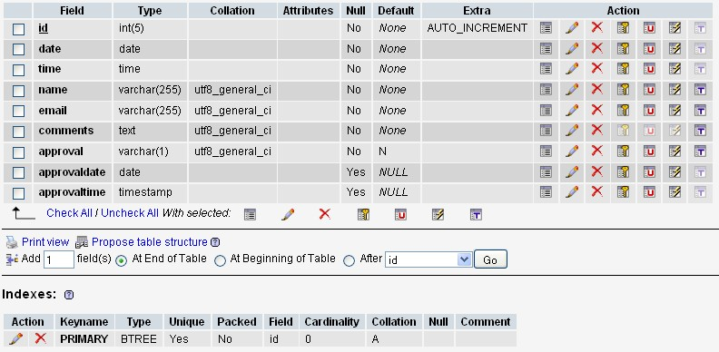

Id = unique sequence number, auto increment, primary key
date = comments posting date
time = comments posting time
name = comments writer’s name
email = comments writer’s email
comments = actual comments
approval = Administrator’s approval, Y= approved N = not yet approved R = Rejected
(default is N).
approvaldate = approval date
approvetime = approval time
Performance – Comment Table

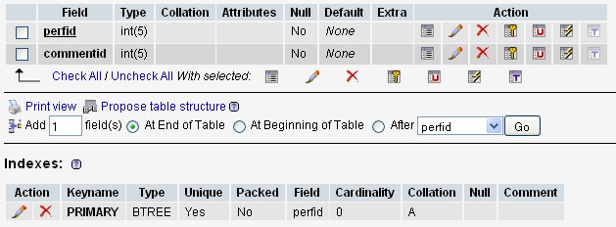

perfid = id of the performance containing comments
commentid = id of the comments.

